**OUTPUT:**

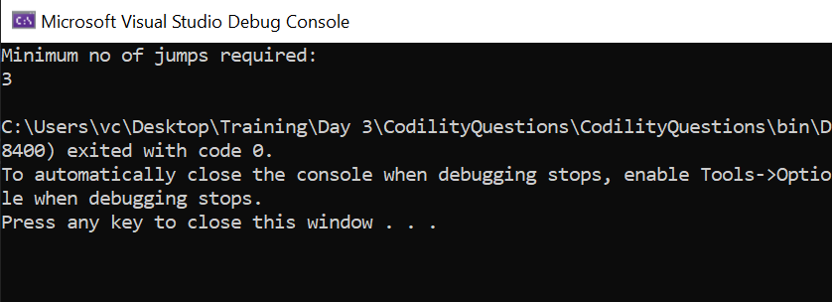

**CODE:**

using System;

using System.Collections.Generic;

using System.Linq;

using System.Text;

using System.Threading.Tasks;

namespace CodilityQuestions

{

internal class Program3

{

static void Main(string[] args)

{

int x = 10, y = 85, d = 30;

Console.WriteLine("Minimum no of jumps required:");

Console.WriteLine(Math.Ceiling((double)(y-x)/(double)30));

}

}

}